Appsters Industry Page Layout
RESTAURANT
Laid out fold by fold against www.appsters.io/industry
 | DETAIL
Slug | restaurant-app-development-company
Meta Title | Restaurant App Development Company | Appsters
Meta Description | Get a restaurant ordering, delivery and loyalty app that syncs with your POS and kitchen. Built by Appsters for single sites and multi brand groups.
Layout Source | www.appsters.io/industry
Live Folds | 23
New Blocks Required | 3
FOLD 1: Hero Banner
Hero Banner
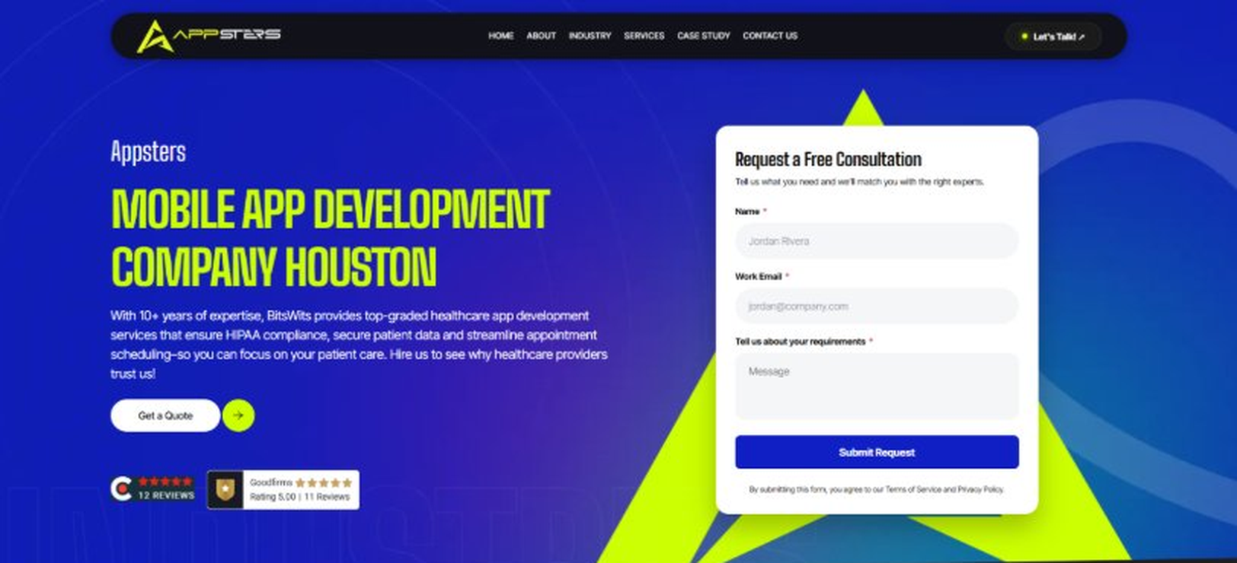
Current live page, www.appsters.io/industry
 | DETAIL
Status | New copy applied
Build Notes | Live block holds H1, sub copy, a Get a Quote button and the Request a Free Consultation form. New copy supplies the H1 and sub copy only.
QA Flag | Live hero copy currently names BitsWits and describes healthcare services. Leftover copy from another build, replace it with the new copy below.
Copy For This Fold
PAGE ELEMENT | COPY (WORD FOR WORD)
H1 (Page Heading) | A Restaurant App Development Company Building Platforms That Keep Tables And Orders Full
Body Copy | Empty tables and cold food are the two things that kill a restaurant's app reviews fastest. As a restaurant app development company, Appsters builds restaurant apps that keep ordering fast, delivery accurate, and loyalty programs worth using. We build platforms for single-location restaurants and multi-brand groups who need software that actually moves orders, not just displays a menu.
FOLD 2: Marquee Strip
Marquee Strip: Turn Your Wildest Ideas Into Powerful Digital Products
Current live page, www.appsters.io/industry
 | DETAIL
Status | No copy change
Build Notes | No new copy in the source document for this fold. Keep the live block exactly as it is.
FOLD 3: Stats Counter
Stats Counter: Work With A Local Mobile App Developer In Houston
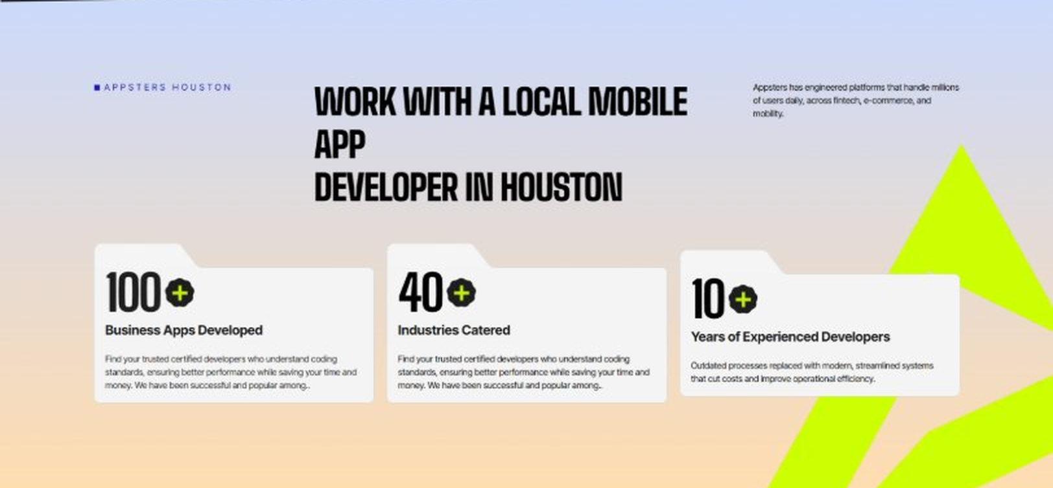
Current live page, www.appsters.io/industry
 | DETAIL
Status | New copy applied
Build Notes | Live block holds 3 counters. New copy holds 6 stats. Either widen the block to 6 or drop two.
Copy For This Fold
PAGE ELEMENT | COPY (WORD FOR WORD)
H2 (Section Heading) | Awarded For Building Restaurant Apps That Keep Kitchens And Customers In Sync
Body Copy | Our restaurant app development work has earned recognition for order accuracy, kitchen integration, and measurable repeat-order gains. Appsters has been recognized for delivering platforms that route orders correctly, sync with POS systems cleanly, and stay reliable through Friday night rushes. Every award reflects tested performance, not a polished pitch.
Stat 1 Number | 40+
Stat 1 Label | Industries Served
Stat 1 Copy | Our experience spans social platforms, marketplaces, fintech, healthcare, and more, with solutions adapted to each sector's demands for security, AI, compliance, and user adoption.
Stat 2 Number | 3000+
Stat 2 Label | Apps and Solutions Delivered
Stat 2 Copy | Thousands of projects executed with an emphasis on speed, AI adoption, stability, and clear ROI across both startup and enterprise environments.
Stat 3 Number | 60+
Stat 3 Label | AI Models Deployed
Stat 3 Copy | Every model is designed for high accuracy, reliable outputs, and performance at scale for mission-critical workflows and more.
Stat 4 Number | 50,000+
Stat 4 Label | Legacy Processes Modernized
Stat 4 Copy | Outdated processes replaced with modern, streamlined systems that cut costs and improve operational efficiency.
Stat 5 Number | 250+
Stat 5 Label | Engineers and Designers
Stat 5 Copy | A global team skilled in native mobile app development, AI-driven ecosystems, cross-platform builds, and enterprise architecture.
Stat 6 Number | 95%
Stat 6 Label | Client Retention
Stat 6 Copy | Long-term partnerships built on trust, consistent delivery, and continuous optimization of live applications.
FOLD 4: Marquee Strip
Marquee Strip: Mobile App Development Services
Current live page, www.appsters.io/industry
 | DETAIL
Status | No copy change
Build Notes | No new copy in the source document for this fold. Keep the live block exactly as it is.
FOLD 5: Services Grid
Services Grid: Our Comprehensive Mobile App Development Services In Houston
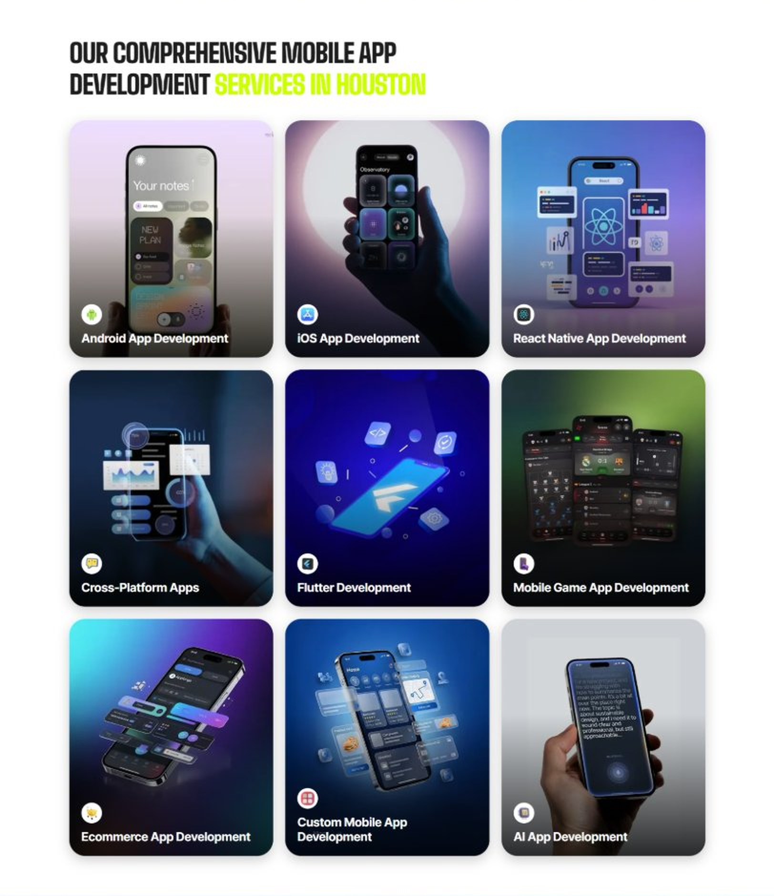
Current live page, www.appsters.io/industry
 | DETAIL
Status | New copy applied
Build Notes | Live grid holds 9 cards. New copy holds 5 services. Either trim the grid to 5 or brief four more services.
Copy For This Fold
PAGE ELEMENT | COPY (WORD FOR WORD)
H2 (Section Heading) | Restaurant Application Development Services Built For Orders That Actually Arrive Right
Body Copy | Strong restaurant platforms sit at the crossroads of ordering, kitchen operations, and delivery logistics. As a restaurant app development company, we connect operational thinking with technical precision. Appsters' senior developers build platforms that support live menu sync, kitchen display integration, and loyalty tools for restaurants of every size.
Service 1 Heading | Restaurant Finder App Development
Service 1 Copy | As restaurant app developers, we build discovery tools that help diners find restaurants based on cuisine, dietary needs, and real wait times instead of outdated star ratings alone.
Service 2 Heading | Food Ordering App Development
Service 2 Copy | Our food ordering app developers build checkout flows that stay fast even during a dinner rush, with menu customization and order accuracy that cuts down on kitchen mistakes.
Service 3 Heading | Food Delivery App Development
Service 3 Copy | As a food delivery app development company, we build routing and driver-assignment systems that get food to customers hot, with live tracking that keeps both the kitchen and the customer informed.
Service 4 Heading | Discounts App Development
Service 4 Copy | Our restaurant discounts app development work helps restaurants reward repeat diners with loyalty points, happy hour deals, and referral perks built directly into the ordering flow.
Service 5 Heading | Restaurant Review & POS Software Development
Service 5 Copy | As a POS software development company, we connect in-app reviews, order history, and point-of-sale data into one system, so owners see real numbers without reconciling five different tools at closing time.
FOLD 6: Case Study CTA
Case Study CTA: HELPP
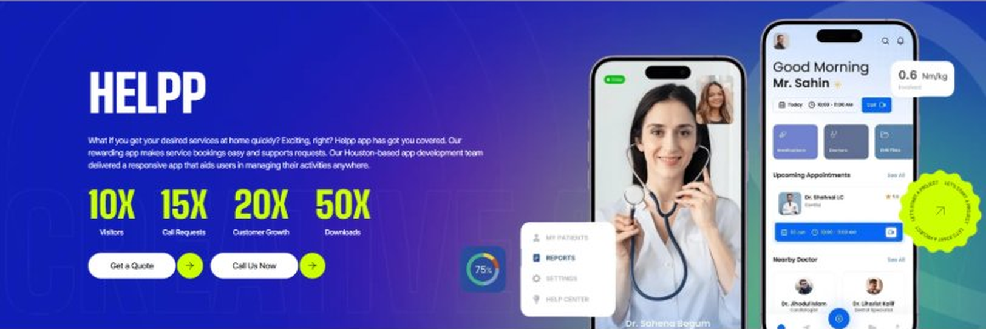
Current live page, www.appsters.io/industry
 | DETAIL
Status | New copy applied
Build Notes | Live block holds a product name, a paragraph, four metric counters and two CTA buttons. New copy supplies the heading and paragraph. Metrics still need to be supplied.
Copy For This Fold
PAGE ELEMENT | COPY (WORD FOR WORD)
H2 (Section Heading) | Restaurant App Developers Who Build Orders That Actually Get Made Right
Body Copy | Launching an ordering app is easy. Keeping order accuracy high during a Friday night rush is the hard part. If you're ready to build restaurant apps that reduce mistakes and increase repeat orders, Appsters is the partner that gets you there. Let's talk about your menu, your kitchen setup, and what a platform built to last actually requires.
FOLD 7: Testimonials
Testimonials: Real Stories From People Who Wanted What’s Next
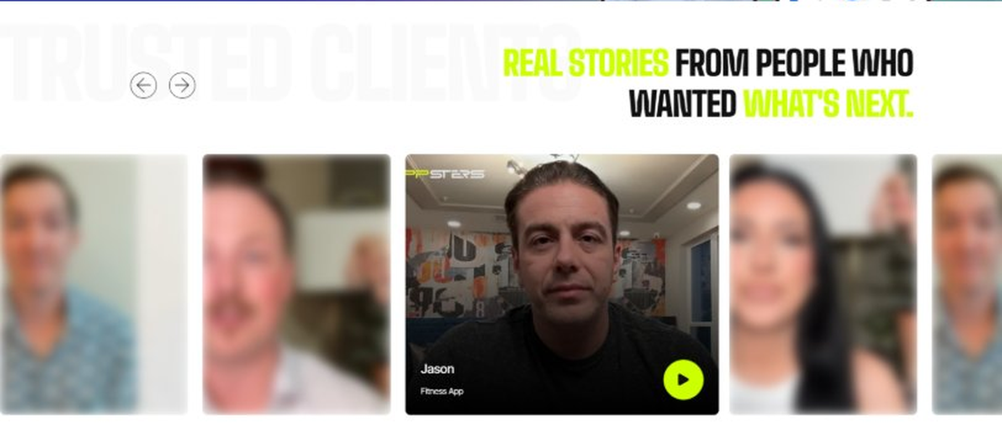
Current live page, www.appsters.io/industry
 | DETAIL
Status | New copy applied
Build Notes | Live block runs video testimonials. New copy is written quotes with attributions. Source document marks this fold design TBD.
Copy For This Fold
PAGE ELEMENT | COPY (WORD FOR WORD)
H2 (Section Heading) | What Our Clients Say
Testimonial 1 Quote | "We used to lose orders during Friday rush because our old system just couldn't keep up. That hasn't happened once since we switched, and our kitchen staff noticed the difference before I even asked them about it."
Testimonial 1 Attribution | Anthony Rizzo, Owner
Testimonial 2 Quote | "Running six locations meant six different loyalty systems before this. Now it's one account for customers no matter which location they walk into, and repeat visits are up because of it."
Testimonial 2 Attribution | Priyanka Shah, Director of Operations
Testimonial 3 Quote | "I was doubtful a delivery app built in-house could compete with the big platforms. It does, and we're not paying thirty percent commission on every order anymore."
Testimonial 3 Attribution | Louis Marchetti, General Manager
Testimonial 4 Quote | "Our kitchen display integration just worked from day one, which almost never happens with new software in a working kitchen. That alone earned a lot of trust from my line cooks."
Testimonial 4 Attribution | Denise Okonkwo, Executive Chef
Testimonial 5 Quote | "What sold me was watching the app hold up during our grand opening weekend, which is usually when everything breaks. Nothing did."
Testimonial 5 Attribution | Samir Haddad, Franchise Owner
Source document note: Testimonial fold, design TBD after content
FOLD 8: Technology Logo Strip
Technology Logo Strip

Current live page, www.appsters.io/industry
 | DETAIL
Status | No copy change
Build Notes | No new copy in the source document for this fold. Keep the live block exactly as it is.
FOLD 9: Why Choose Us
Why Choose Us: Compelling Reasons To Choose Us As A Trustable App Development Company In Houston
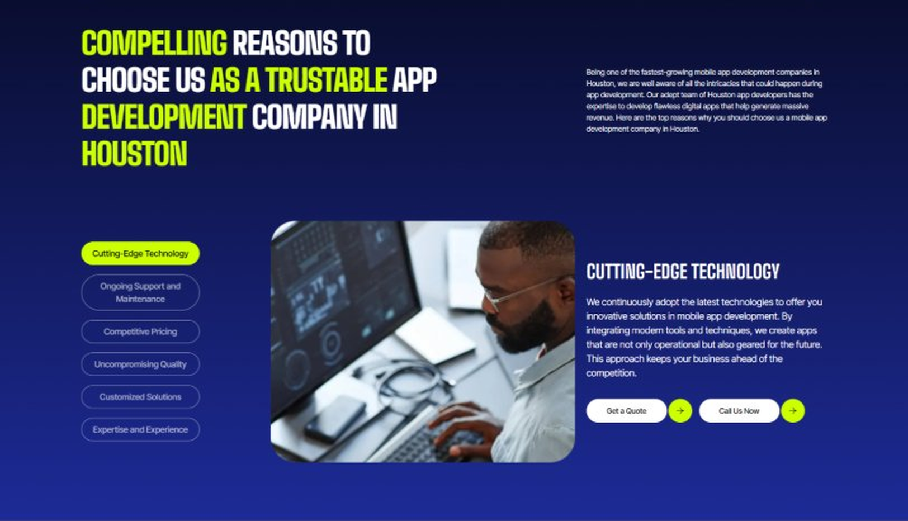
Current live page, www.appsters.io/industry
 | DETAIL
Status | New copy applied
Build Notes | Live block holds 6 tabs. New copy holds 6 reasons. Clean one to one fit, no design change needed.
Copy For This Fold
PAGE ELEMENT | COPY (WORD FOR WORD)
H2 (Section Heading) | Why Restaurant Groups Choose Appsters As Their Trusted Restaurant App Partner
Body Copy | Choosing a restaurant app development partner shapes whether your kitchen runs smoothly during a rush or falls behind on tickets. Our team blends operational thinking, engineering discipline, and POS expertise to build apps that actually speed up service.
Reason 1 Heading | Speed-First Architecture
Reason 1 Copy | We design every feature around order-to-kitchen speed, backed by real service data rather than assumptions.
Reason 2 Heading | Built-In POS Compatibility
Reason 2 Copy | Integration isn't bolted on later. Our systems are designed to sync with the POS systems restaurants already run on.
Reason 3 Heading | Rush-Hour Engineering
Reason 3 Copy | Our architecture is stress-tested for Friday night volume, so a busy service becomes a good problem, not a crashed app.
Reason 4 Heading | Kitchen-First Usability
Reason 4 Copy | From order tickets to prep timing, we design kitchen-facing tools simple enough to use with wet hands and no time to spare.
Reason 5 Heading | Transparent Development Cycles
Reason 5 Copy | We follow sprint cadences with review checkpoints and shared roadmaps, so clients always know what's shipping and what's improving.
Reason 6 Heading | Long-Term Platform Thinking
Reason 6 Copy | We structure apps as ecosystems that evolve with new menu items and expanding locations, built for longevity rather than a single launch cycle.
FOLD 10: Sector Tabs
Sector Tabs: Serving 40+ Sectors With Mobile App Development In Houston
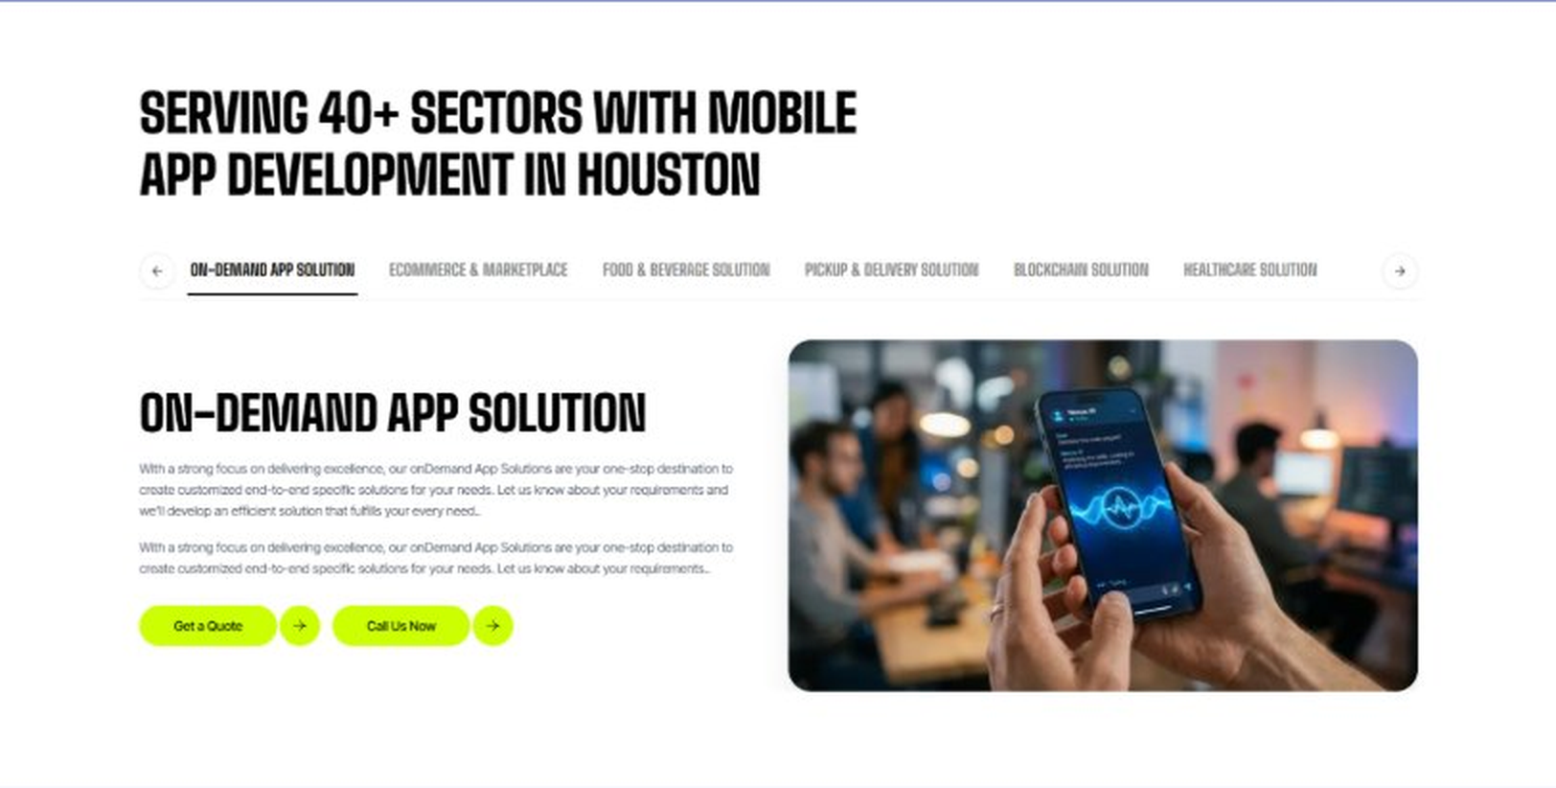
Current live page, www.appsters.io/industry
 | DETAIL
Status | New copy applied
Build Notes | Live block holds 6 sector tabs. New copy holds 5 solutions. Drop one tab or brief a sixth solution.
Copy For This Fold
PAGE ELEMENT | COPY (WORD FOR WORD)
H2 (Section Heading) | Restaurant App Solutions Built For Every Part Of The Dining Experience
Body Copy | Appsters delivers restaurant app solutions that cover everything from event catering to kitchen operations. Our systems are architected by senior restaurant app developers who focus on order accuracy, speed, and stable performance. Through our restaurant app development services, we help restaurant groups build platforms that feel fast, reliable, and built to handle a real dinner rush.
Solution 1 Heading | Event Management Apps
Solution 1 Copy | Our event management tools help restaurants coordinate private dining events and catering bookings, managing menus, headcounts, and vendor logistics from one dashboard.
Solution 2 Heading | Corporate Events Apps
Solution 2 Copy | We build catering coordination apps for restaurants that handle corporate lunch orders and office catering accounts, replacing phone orders with something that actually tracks recurring accounts.
Solution 3 Heading | Subscription-Based Meal Apps
Solution 3 Copy | We build subscription-based meal plan tools that let regular customers prepay for weekly meals, giving restaurants predictable recurring revenue instead of relying purely on walk-ins.
Solution 4 Heading | Cloud Kitchen Apps
Solution 4 Copy | We build cloud kitchen apps for delivery-only concepts, letting restaurant groups launch new virtual brands from an existing kitchen without opening a new physical location.
Solution 5 Heading | Inventory Management Apps
Solution 5 Copy | Our inventory management apps keep ingredient counts accurate in real time, flagging low stock before a popular menu item has to get pulled mid-service.
FOLD 11: Engagement Models Table
Engagement Models Table: Flexible Engagement Models For Any App Development Need
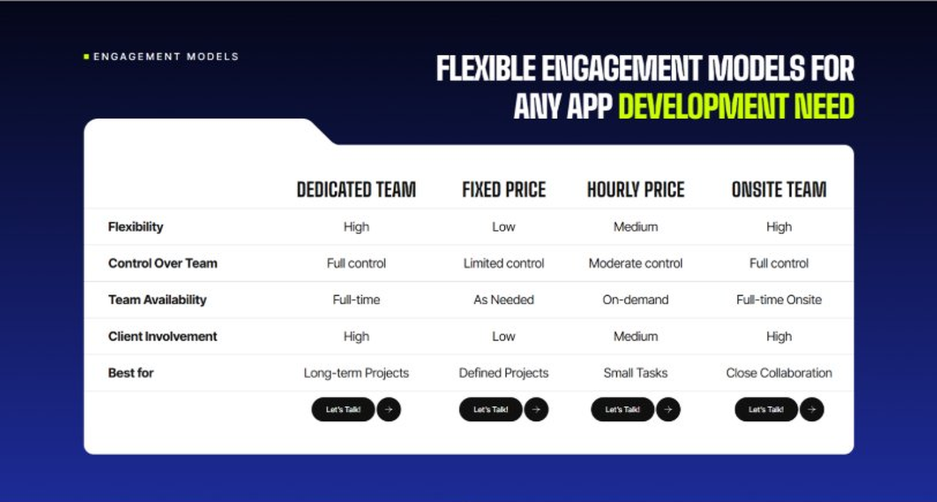
Current live page, www.appsters.io/industry
 | DETAIL
Status | No copy change
Build Notes | No new copy in the source document for this fold. Keep the live block exactly as it is.
FOLD 12: Game App CTA
Game App CTA: Into Engaging Mobile Games
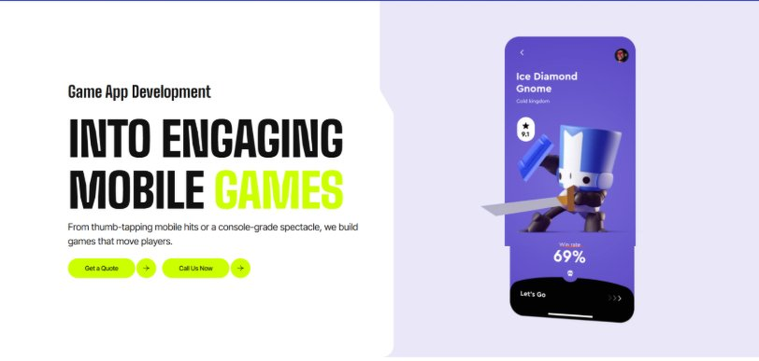
Current live page, www.appsters.io/industry
 | DETAIL
Status | No copy change
Build Notes | No new copy in the source document for this fold. Keep the live block exactly as it is.
FOLD 13: Collaboration And Client Logos
Collaboration And Client Logos
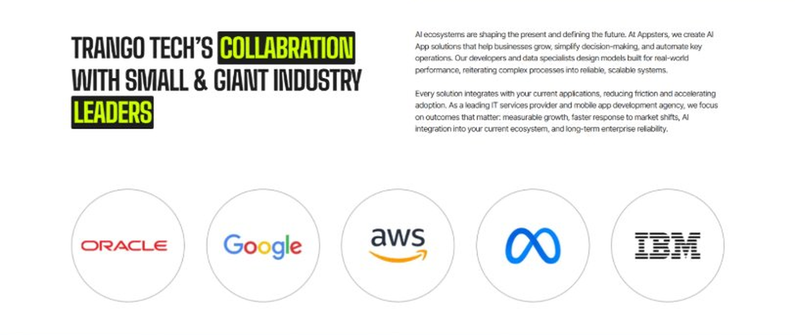
Current live page, www.appsters.io/industry
 | DETAIL
Status | No copy change
Build Notes | No new copy in the source document for this fold. Keep the live block exactly as it is.
QA Flag | Live heading reads "Trango Tech’s Collabration with Small & Giant Industry Leaders". That is a competitor name plus a spelling error sitting live on the page. Fix regardless of this content drop.
FOLD 14: Recognition CTA Banner
Recognition CTA Banner

Current live page, www.appsters.io/industry
 | DETAIL
Status | New copy applied
Build Notes | Live block holds a headline and two CTA buttons. New copy supplies the heading and paragraph.
Copy For This Fold
PAGE ELEMENT | COPY (WORD FOR WORD)
H2 (Section Heading) | Tables Are Filling Up Somewhere Else. Is Your Platform Ready To Launch?
Body Copy | Every day you wait is a day another restaurant gets ahead on speed and loyalty. Let's build a restaurant app that keeps orders accurate and diners coming back. Talk to Appsters today, and let's figure out what your first release actually needs to look like.
FOLD 15: Market Presence And Office Map
Market Presence And Office Map: Expand Your Market Presence
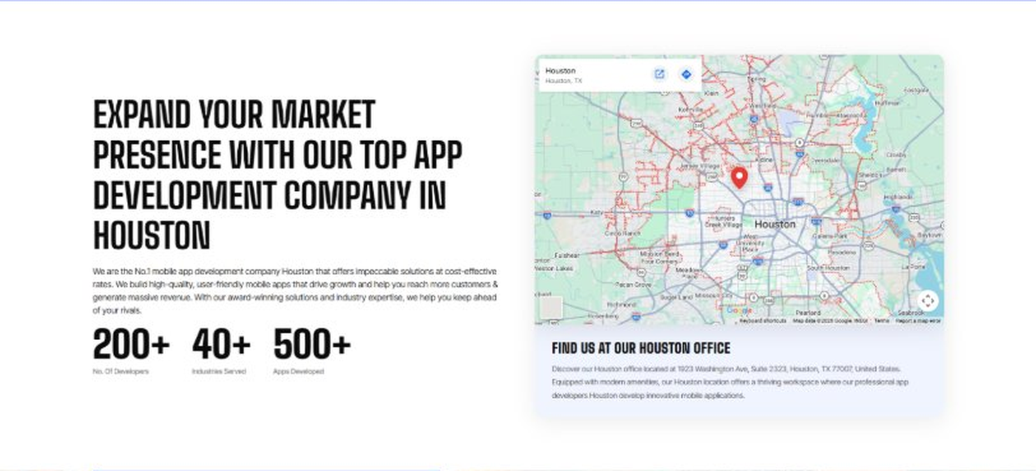
Current live page, www.appsters.io/industry
 | DETAIL
Status | New copy applied
Build Notes | Live block holds a heading, a paragraph, three counters and the office map. New copy supplies the heading and paragraph.
Copy For This Fold
PAGE ELEMENT | COPY (WORD FOR WORD)
H2 (Section Heading) | Food Ordering App Development Company Expertise Behind Every Restaurant Platform We Build
Body Copy | As a team that knows how to develop mobile restaurant apps at scale, we bring deep experience across ordering, delivery, and kitchen operations. Our engineers have shipped AI-based food delivery apps for restaurant groups running dozens of locations, giving us a deeper bench than studios that only build single-restaurant menu apps. React Native, Swift, Kotlin, Node.js, and POS integration APIs form our core stack, paired with AI models tuned for demand forecasting, route optimization, and fraud detection. Where most competitors treat delivery as a bolt-on, we design it into the ordering experience from day one.
FOLD 16: Portfolio
Portfolio: Quick Glimpse On Our Portfolio

Current live page, www.appsters.io/industry
 | DETAIL
Status | New copy applied
Build Notes | Live block holds a heading, a paragraph and one CTA. New copy holds an intro plus 4 named product cards. Source document marks this fold design TBD.
Copy For This Fold
PAGE ELEMENT | COPY (WORD FOR WORD)
H2 (Section Heading) | Restaurant Products Engineered For Faster Service And Repeat Visits
Body Copy | Appsters builds restaurant platforms that behave like long-term operational infrastructure, not a one-off menu app. Our solutions stand out because they blend ordering logic, kitchen integration, and customer behavior analytics in one stable system. Every product is architected for speed, accuracy, and real repeat business.
Product 1 Heading | TableTurn
Product 1 Copy | TableTurn is a reservation and waitlist app that gives hosts real-time table availability and sends diners accurate wait time updates, cutting down on the crowd standing at the host stand.
Product 2 Heading | OrderFlow
Product 2 Copy | OrderFlow is an ordering and kitchen display app that routes orders directly to the right station, reducing ticket errors and speeding up table turnover during peak hours.
Product 3 Heading | DriverDash
Product 3 Copy | DriverDash is a delivery driver app built for restaurant groups running their own delivery fleet instead of relying on third-party platforms and their commission fees.
Product 4 Heading | LoyaltyBite
Product 4 Copy | LoyaltyBite is a rewards app that tracks visits and spending across multiple restaurant locations, giving diners one loyalty account instead of a separate punch card for every location.
Source document note: Portfolio fold, design TBD after content
FOLD 17: Tech Stack Tabs
Tech Stack Tabs: Mobile App Development, A Tech Stack For The Bold
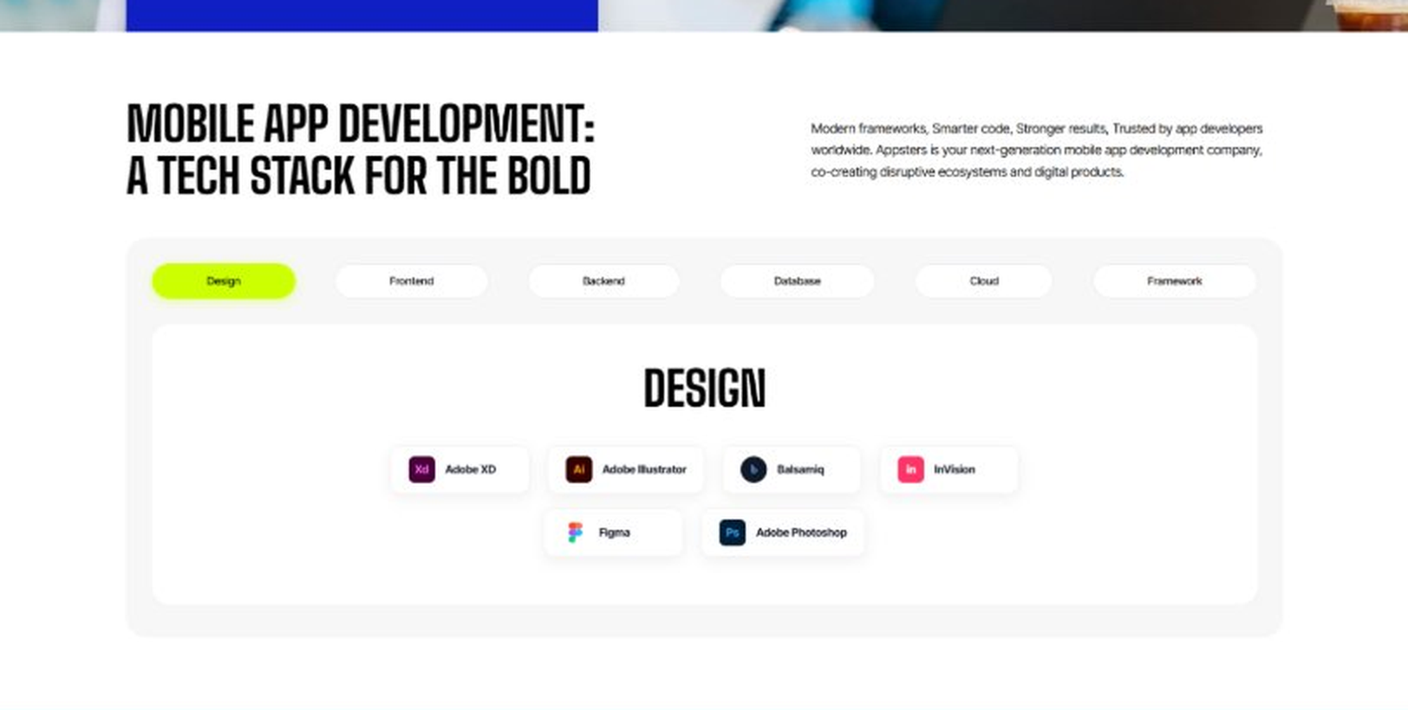
Current live page, www.appsters.io/industry
 | DETAIL
Status | New copy applied
Build Notes | Live block holds 6 category tabs with tool logos. New copy supplies the heading and paragraph, the tab contents stay as they are.
Copy For This Fold
PAGE ELEMENT | COPY (WORD FOR WORD)
H2 (Section Heading) | Technology Stack That Powers High-Performance Restaurant Applications
Body Copy | Our engineering foundation supports live ordering, kitchen integration, and platform-wide scalability. Through our restaurant application development services, we use Swift, Kotlin, Flutter, React Native, Node.js, POS integration protocols, and secure cloud infrastructure alongside AI-driven forecasting engines. Every stack decision reinforces speed, accuracy, and long-term flexibility so your platform can grow without a rebuild.
FOLD 18: Process
Process: App Development Process
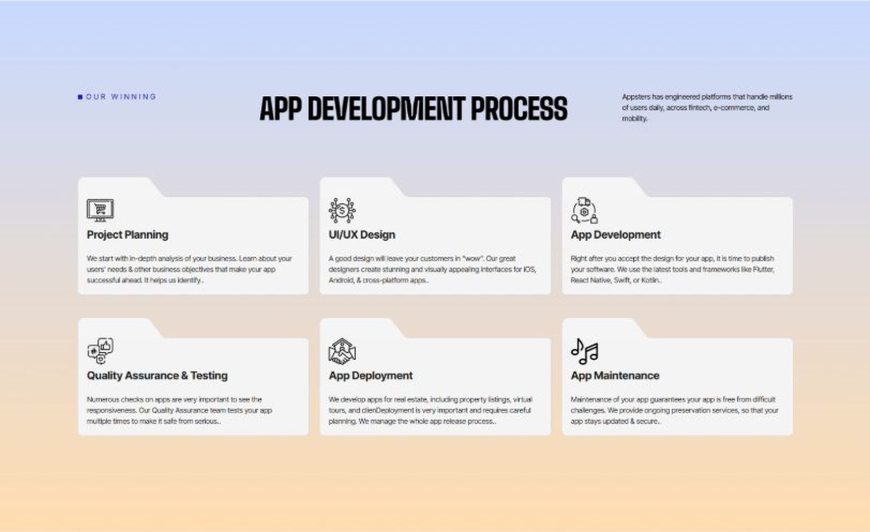
Current live page, www.appsters.io/industry
 | DETAIL
Status | New copy applied
Build Notes | Live block holds 6 step cards. New copy holds 8 steps. Either widen the block to 8 or merge two steps.
Copy For This Fold
PAGE ELEMENT | COPY (WORD FOR WORD)
H2 (Section Heading) | Restaurant App Development Process Built For Platforms That Handle A Real Rush
Body Copy | A restaurant platform needs more than a nice-looking menu. It needs structure, clarity, and a process engineered for speed, accuracy, and reliability from day one. Our restaurant app development process aligns operational goals with technical roadmaps so every phase moves with intention.
Step 1 Heading | App Idea & Research
Step 1 Copy | Every project begins with structured discovery, where our teams map ordering patterns, kitchen workflows, and delivery logistics. We benchmark performance against existing platforms and define what will actually speed up service. By the time research closes, the product's purpose, risks, and growth path are already clear.
Step 2 Heading | Strategic Planning & Consultation
Step 2 Copy | Here we translate research into a measurable plan. Our strategists define the technical architecture, POS integration needs, and delivery milestones needed to build your AI restaurant mobile app the right way, from the first sprint.
Step 3 Heading | Wireframing & Prototyping
Step 3 Copy | We turn ideas into tangible user journeys. Wireframes capture ordering flows, kitchen display screens, and delivery driver interfaces in a visual structure stakeholders can react to before a single line of code gets written.
Step 4 Heading | App Development
Step 4 Copy | This is where engineering takes over. Our developers implement ordering systems, kitchen integrations, and delivery routing with the same discipline a food app development company applies to order accuracy and uptime. Development stays sprint-driven and transparent throughout.
Step 5 Heading | Expert QA & Testing
Step 5 Copy | Quality assurance covers far more than bug hunting. We validate order accuracy under peak load, POS sync reliability, and cross-device behavior. Only stable, predictable behavior earns approval to move forward.
Step 6 Heading | App Launch
Step 6 Copy | Launch is a coordinated rollout, not a leap of faith. We manage store compliance, staff training materials, and final performance checks so your platform enters service ready to hold a real dinner rush.
Step 7 Heading | Deployment
Step 7 Copy | Our deployment pipelines are built for consistency and safety. We configure cloud infrastructure, optimize for peak ordering windows, and calibrate autoscaling so your app performs the same on a slow Tuesday as it does on a packed Friday.
Step 8 Heading | Maintenance & Support
Step 8 Copy | Post-launch, we keep monitoring order accuracy, refining kitchen routing logic, patching vulnerabilities, and responding to new POS or app store requirements, so your platform keeps improving long after day one.
Source document note: Process fold, design TBD after content
FOLD 19: Blog Posts
Blog Posts: Our Related Blog Posts
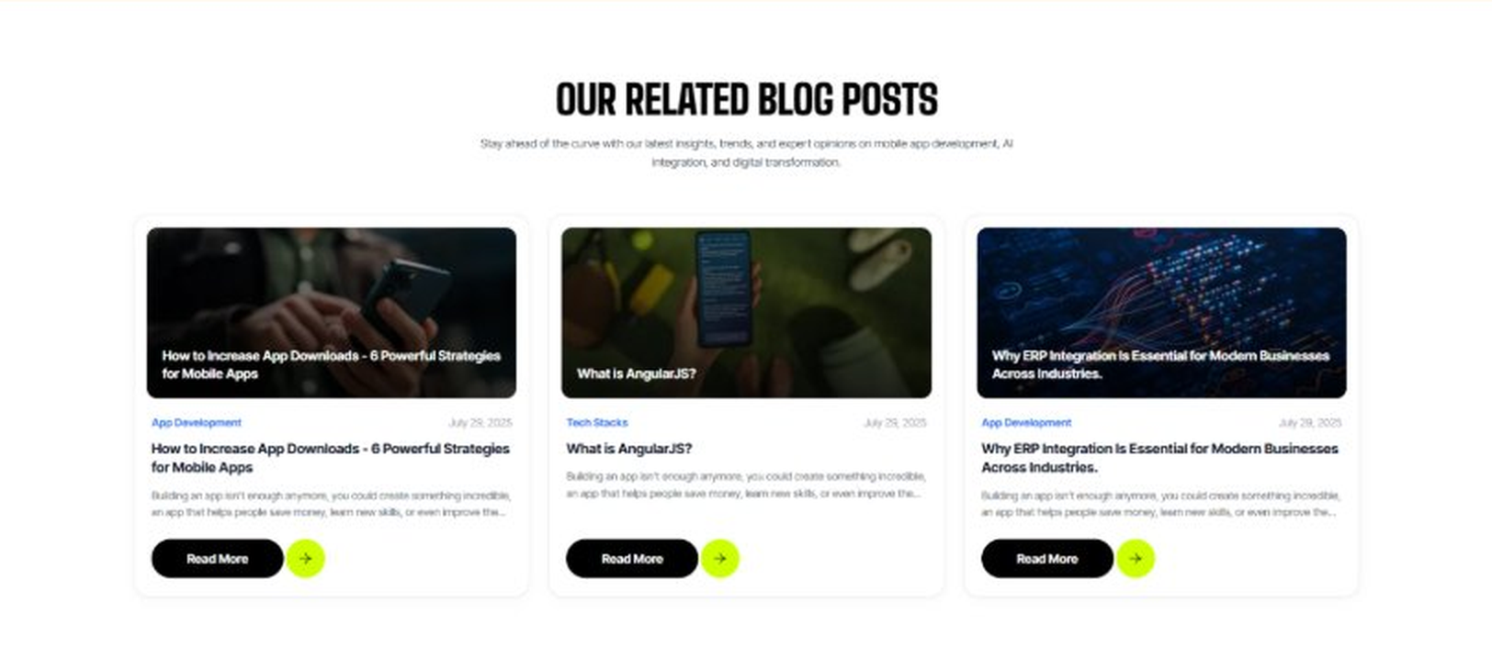
Current live page, www.appsters.io/industry
 | DETAIL
Status | No copy change
Build Notes | No new copy in the source document for this fold. Keep the live block exactly as it is.
FOLD 20: FAQs
FAQs: Your Questions, Our Clarity
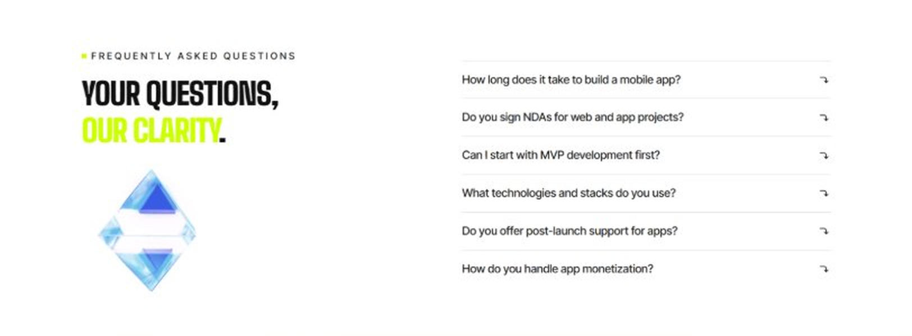
Current live page, www.appsters.io/industry
 | DETAIL
Status | New copy applied
Build Notes | Live block holds 6 accordion rows. New copy holds 6 questions and answers. Clean one to one fit.
Copy For This Fold
PAGE ELEMENT | COPY (WORD FOR WORD)
H2 (Section Heading) | Frequently Asked Questions
FAQ 1 Question | How long does it typically take to build a fully functional restaurant app?
FAQ 1 Answer | Timelines depend on POS integration, delivery fleet setup, and feature scope. Most projects take 10 to 18 weeks for a stable release, including design, engineering, QA, and pilot testing. As a restaurant app development company, we provide clear milestones from day one.
FAQ 2 Question | Can Appsters build an AI restaurant app with demand forecasting?
FAQ 2 Answer | Yes. We build AI restaurant apps with demand forecasting, dynamic pricing, and inventory alerts baked into the core architecture, not added as an afterthought.
FAQ 3 Question | Do you handle food delivery app development company-style features in-house, or only ordering?
FAQ 3 Answer | Both. Many of our restaurant app developers have direct experience building full delivery fleet management, so you're not limited to pickup and dine-in ordering alone.
FAQ 4 Question | What makes Appsters different from other restaurant app development companies?
FAQ 4 Answer | We treat order accuracy, POS compatibility, and delivery speed as core product decisions, not add-ons. Most restaurant app development companies focus on UI first and operations later. We do both from the start.
FAQ 5 Question | Can you handle sudden order spikes during a rush or a big promotion?
FAQ 5 Answer | Yes. Our architecture is stress-tested for exactly this kind of load, so a rush becomes a good night instead of a crashed app.
FAQ 6 Question | What ongoing support do you provide after launch?
FAQ 6 Answer | Our restaurant app development services include post-launch monitoring, feature updates, POS sync checks, and infrastructure scaling, so your platform keeps improving long after release.
FOLD 21: Locations
Locations: Our Global Presence
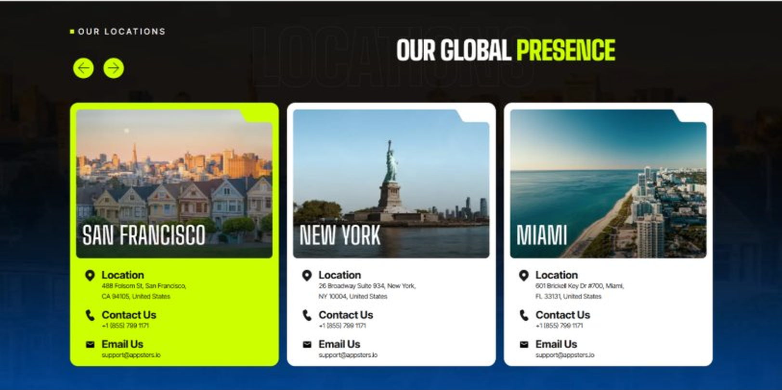
Current live page, www.appsters.io/industry
 | DETAIL
Status | No copy change
Build Notes | No new copy in the source document for this fold. Keep the live block exactly as it is.
FOLD 22: Contact Form
Contact Form: Connect With Us
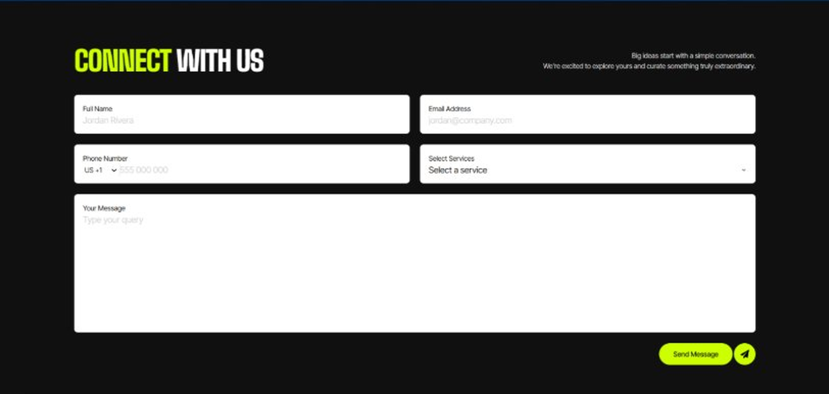
Current live page, www.appsters.io/industry
 | DETAIL
Status | No copy change
Build Notes | No new copy in the source document for this fold. Keep the live block exactly as it is.
FOLD 23: Footer
Footer
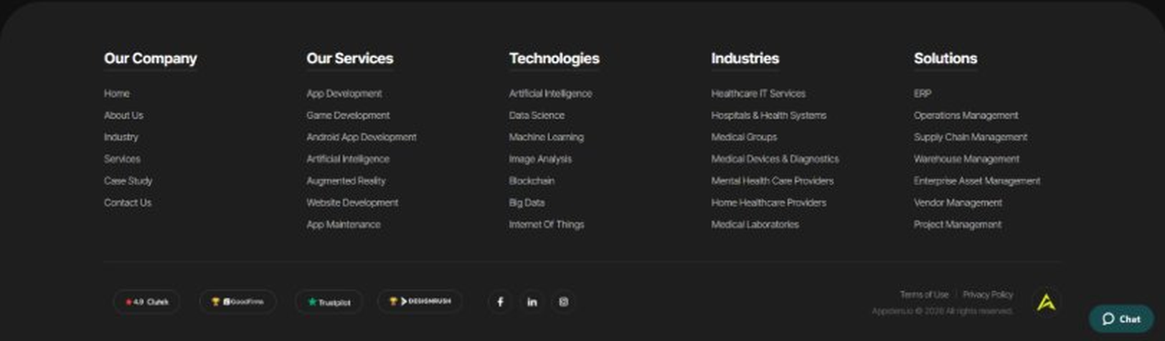
Current live page, www.appsters.io/industry
 | DETAIL
Status | No copy change
Build Notes | No new copy in the source document for this fold. Keep the live block exactly as it is.
NEW BLOCKS REQUIRED
The three blocks below are in the source content but have no matching section anywhere on the current /industry page. Each one needs a new block built.
NEW BLOCK: Distinct Features That Set Our Restaurant Apps Apart
 | DETAIL
Status | No equivalent block on the live page
Placement | Suggested placement: directly after Fold 5, reusing the services card grid styling.
Copy For This Block
PAGE ELEMENT | COPY (WORD FOR WORD)
H2 (Section Heading) | Distinct Features That Set Our Restaurant Apps Apart
Feature 1 Heading | Dashboard & Admin Panel
Feature 1 Copy | A centralized control center gives owners visibility into sales, order volume, and staff performance without digging through raw POS reports.
Feature 2 Heading | Push Notifications
Feature 2 Copy | Smart, behavior-based notifications bring diners back with the right offer at the right moment instead of generic blasts nobody opens.
Feature 3 Heading | Digital Menu
Feature 3 Copy | A structured digital menu lets diners browse dishes, dietary tags, and daily specials without flipping through a printed insert.
Feature 4 Heading | Order Tracking
Feature 4 Copy | Real-time order tracking keeps customers informed from kitchen to doorstep, cutting down on the anxious calls asking where the food is.
Feature 5 Heading | Social Media Integration
Feature 5 Copy | Direct sharing lets diners post meals and reviews straight to their existing social platforms, turning good food into free marketing.
NEW BLOCK: Industries We Serve
 | DETAIL
Status | No equivalent block on the live page
Placement | Suggested placement: directly after Fold 10, as a card grid rather than tabs.
Copy For This Block
PAGE ELEMENT | COPY (WORD FOR WORD)
H2 (Section Heading) | Industries We Serve
Body Copy | One Codebase. Infinite Industries. Our web, app, and AI solutions are built to perform, scale, and adapt while setting industry standards and redefining what's possible for businesses everywhere.
Industry 1 Heading | Fintech
Industry 1 Copy | We co-create secure, compliant fintech apps that simplify payments, investments, and trading, using the same transaction infrastructure we build for dine-in and delivery payments.
Industry 2 Heading | Healthcare
Industry 2 Copy | We develop HIPAA-compliant healthcare apps that bridge doctors, patients, and data, applying the same real-time order and scheduling logic we use for restaurant reservations.
Industry 3 Heading | Education
Industry 3 Copy | Our education apps gamify learning and power virtual classrooms, borrowing the same loyalty and engagement mechanics we use to bring diners back.
Industry 4 Heading | Real Estate
Industry 4 Copy | We design real estate apps that help buyers, sellers, and agents close deals faster, using the same location-based discovery logic we build for restaurant finder tools.
Industry 5 Heading | Automotive
Industry 5 Copy | From fleet dashboards to car rental apps, we digitize automotive operations using the same routing expertise behind our delivery driver apps.
Industry 6 Heading | Music
Industry 6 Copy | We create streaming apps and artist marketplaces, applying the same recommendation engines we use to suggest menu items diners are likely to order.
Industry 7 Heading | Social Media
Industry 7 Copy | We build social platforms that are scalable and sticky, drawing on the same engagement mechanics that keep diners posting about their meals.
Industry 8 Heading | Logistics
Industry 8 Copy | We power logistics apps with route optimization and real-time tracking, using the same infrastructure behind our restaurant delivery fleets.
Industry 9 Heading | Ecommerce
Industry 9 Copy | We build ecommerce apps with frictionless checkouts and AI product recommendations, backed by the same ordering logic we use across our restaurant platforms.
NEW BLOCK: Advanced Technologies That Power Our Restaurant Apps
 | DETAIL
Status | No equivalent block on the live page
Placement | Suggested placement: directly after Fold 17, reusing the services card grid styling.
Copy For This Block
PAGE ELEMENT | COPY (WORD FOR WORD)
H2 (Section Heading) | Advanced Technologies That Power Our Restaurant Apps
Body Copy | As a restaurant app development company built around what's next, we don't stop at menus and checkout. Every restaurant app developer on our team stays current with tools that keep platforms competitive, from AI demand forecasting to live commerce. Unlike most restaurant app development companies still catching up on food ordering app development trends, we're already building AI-based restaurant apps with these capabilities baked in.
Technology 1 Heading | AI Integrated Restaurant Apps
Technology 1 Copy | We build AI Integrated Restaurant Apps with demand forecasting, dynamic menu pricing, and automated inventory alerts, helping owners make decisions before a shortage happens, not after.
Technology 2 Heading | Payment Gateway Integration
Technology 2 Copy | Secure, PCI-compliant payment gateway integration lets your platform handle dine-in, delivery, and catering payments without third-party friction.
Technology 3 Heading | Cloud Solutions
Technology 3 Copy | Our cloud solutions keep ordering platforms fast and reliable, with autoscaling infrastructure built to absorb weekend rush traffic.
Technology 4 Heading | MVP For Restaurant Apps
Technology 4 Copy | When you need to validate an idea fast, our MVP for Restaurant Apps approach gets a functional, testable product into your customers' hands without a twelve-month build cycle.
Technology 5 Heading | API Integration
Technology 5 Copy | We connect your platform to POS systems, delivery networks, and other restaurant ecosystems through clean, well-documented API integration.

